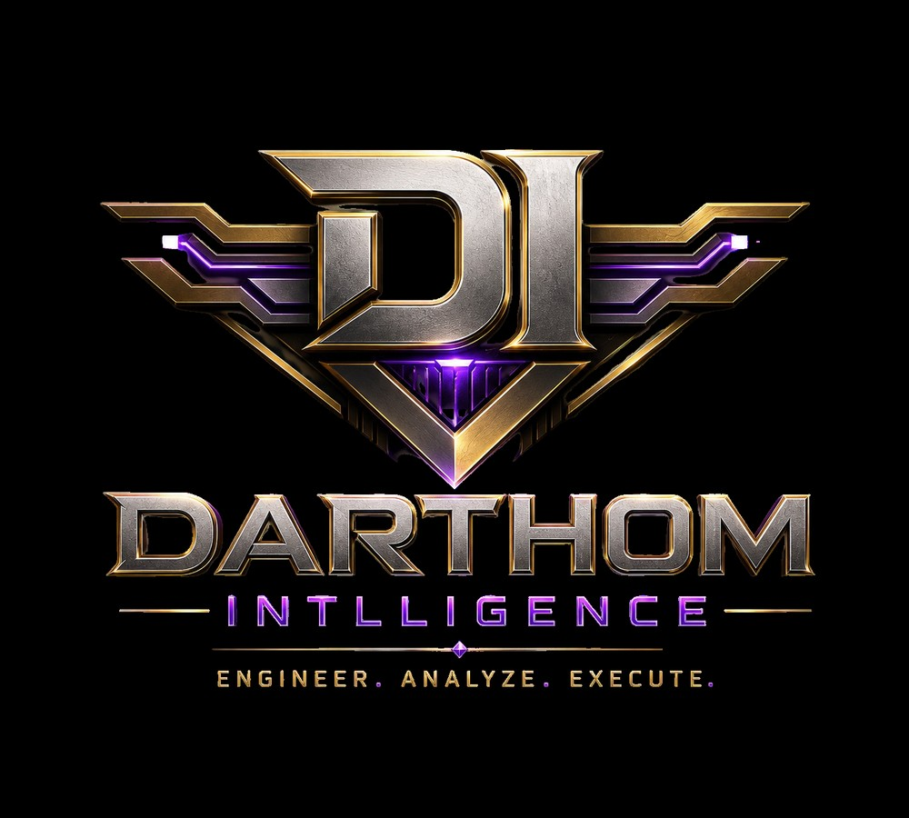
DARTHOM INTLLIGENCE
Real Resume & Backstory Packet
ENGINEER. ANALYZE. EXECUTE.
Private engineering, AI systems, data intelligence, infrastructure, product strategy, and opportunity execution.


Profile Packet Overview
This packet turns the original Darthom Intlligence roster into resume-style professional profiles with matched portraits, backstories, selected work, career timelines, and operator value statements.
The roster is written as a serious private/freelance engineering collective: people who have created their own opportunities, built technical systems privately, and now operate under one company standard.
The profiles avoid pretending to be externally verified employment records. They are built as polished internal/company profile drafts that can be edited further before publication.

Image Assignment Map
Person | Role | Assigned Image(s) | Why this match works
Skyes Over London / Gray Skyes | President | Gray Skyes.png, Gray skyes2.png | Two images used because the president profile needs both an executive portrait and command-office presence.
Darius Hartwell | Chief Intelligence Architect | male6.png | Assigned male6.png because the portrait reads as senior, strategic, and intelligence-focused.
Talia Monroe | Lead AI Systems Engineer | female1.png | Assigned female1.png because the strong green suit and direct presence fit the lead systems engineer profile.
Roman Ellis | Senior Full-Stack Engineer | male4.png | Assigned male4.png because the portrait reads modern, technical, and product-build oriented.
Nyla Voss | Data Operations Strategist | female3.png | Assigned female3.png because the controlled, formal look fits a data operations strategist.
Kendrick Vale | Security & Infrastructure Engineer | male3.png | Assigned male3.png because the structured, dark green executive look fits security and infrastructure ownership.
Amara Stone | Product Intelligence Engineer | female4.png | Assigned female4.png because the polished executive stance fits product strategy and client-facing leadership.
Jalen Cross | Opportunity & Systems Closer | male2.png | Assigned male2.png because the formal, composed portrait fits partnership and deal-closing authority.
Note: The supplied folder contained two extra individual portraits beyond the current eight-person roster. They are retained in Assets/Unused_Alternates for future additions or swaps.

Company Capability Stack
- Executive command: Skyes Over London / Gray Skyes - Standards, partnerships, proof-first delivery, operating discipline
- Intelligence architecture: Darius Hartwell - Opportunity maps, lead scoring, market signals, decision dashboards
- AI systems: Talia Monroe - AI workflows, agents, document automation, human-in-the-loop tooling
- Product surfaces: Roman Ellis - Client portals, dashboards, internal tools, monetizable MVPs
- Data operations: Nyla Voss - Data cleaning, KPI systems, reporting quality, source documentation
- Security & infrastructure: Kendrick Vale - Cloud posture, access control, backups, deployments, technical risk
- Product intelligence: Amara Stone - Offer design, MVP scoping, product narratives, monetization paths
- Opportunity closing: Jalen Cross - Discovery, proposals, partnerships, deal flow, revenue movement

Skyes Over London / Gray Skyes  President  Department: Executive Leadership  Location: Phoenix command lane with multi-state operating scope  Contact: Executive contact routed through Skyes Over London / SOLEnterprises public channels | 
PROFESSIONAL SUMMARY
Executive operator and systems builder leading Darthom Intlligence with proof-first standards, AI infrastructure discipline, contract-aware delivery, and real-world operating pressure. Gray functions as the command layer between engineering talent, client trust, opportunity validation, and revenue-producing deployment.
CORE COMPETENCIES
Executive operating systems | AI infrastructure and control planes
Contract and partnership strategy | Multi-state operations
Governance-first delivery | Proof artifacts and evidence packs
Procurement-grade trust surfaces | Technical product direction
RESUME TIMELINE
Role | Period | Scope
President, Darthom Intlligence | 2026 - Present | Sets strategy, approves major opportunities, aligns AI/data engineering with monetizable delivery, and enforces proof-first standards across the team.
Founder / Operating Company Lead, Skyes Over London | 2023 - Present | Built a public-facing ecosystem around AI infrastructure, portals, governance, proof artifacts, and operator-grade web systems.
Private Operator / Network Architect | 2018 - 2023 | Built contractor networks, time-critical routing systems, credibility surfaces, and operational playbooks across regulated service lanes.
SELECTED WORK / PROOF PROJECTS
- Governed AI platform family with gateway, IDE, and patch-driven delivery lanes
- Authority-grade public trust surfaces for B2B and procurement conversations
- Multi-state operating discipline for Arizona, Texas, Colorado, and Illinois activity
- Proof-first delivery framework involving logs, smoke tests, exports, and verification statements
BACKSTORY
Gray comes from the operator side of technology, where tools only matter if they move contracts, protect accountability, and survive real deployment. The president seat exists because Darthom Intlligence needs more than builders. It needs a person who can turn private engineering strength into an organized company with standards, receipts, and deal movement. Gray brings the pressure-tested mindset of logistics, contractor networks, governed systems, and executive communication into an AI/data intelligence company that must look serious and perform serious.
FIT INSIDE DARTHOM INTLLIGENCE
Gray keeps the team from drifting into theory. The president role makes sure every build has a buyer, every claim has proof, every system has ownership, and every opportunity has a lane to close.
EDUCATION / CONTINUING DEVELOPMENT
Self-directed executive engineering, AI infrastructure, operations architecture, contract systems, and platform governance development.

Darius Hartwell  Chief Intelligence Architect  Department: Intelligence Architecture  Location: Remote-first / Phoenix-aligned operations  Contact: darius.hartwell@darthom-intlligence.example | 
PROFESSIONAL SUMMARY
Private data intelligence operator who turns scattered business information into opportunity maps, lead-scoring models, client-value signals, and decision-ready dashboards. Darius owns the intelligence layer that tells Darthom Intlligence where the money is hiding and what should be built next.
CORE COMPETENCIES
Data intelligence architecture | Opportunity mapping
Market signal research | Lead scoring
Competitive tracking | Dashboard strategy
Data product design | Revenue-focused analytics
RESUME TIMELINE
Role | Period | Scope
Chief Intelligence Architect, Darthom Intlligence | 2026 - Present | Leads the company intelligence model, converts public and client-provided data into revenue-focused opportunity maps, and supports engineering and sales decisions.
Independent Data Intelligence Consultant | 2021 - 2026 | Built lead intelligence systems, KPI dashboards, market maps, and lightweight data products for owner-operators, consultants, and technical founders.
Freelance Research Systems Builder | 2018 - 2021 | Created private research folders, prospect databases, competitor trackers, and reporting templates for solo businesses and small teams.
SELECTED WORK / PROOF PROJECTS
- Opportunity Heatmap: lead-priority scoring model for local B2B services
- Client Value Ledger: dashboard for ranking accounts by margin, renewal risk, and next-best offer
- Competitor Movement Tracker: private watchlist combining public updates, pricing signals, and service changes
- Intelligence Brief Engine: repeatable research template that turns raw notes into executive-ready recommendations
BACKSTORY
Darius learned early that most companies are sitting on useful data but lack the discipline to turn it into action. He built his private practice around messy spreadsheets, broken CRMs, scattered notes, and owners who needed clarity fast. Over time, he became the person people called when they did not need another report, but needed to know where the opportunity was. At Darthom Intlligence, that private operator instinct becomes the company intelligence spine.
FIT INSIDE DARTHOM INTLLIGENCE
Darius gives Darthom Intlligence foresight. He identifies what markets to enter, which clients to pursue, which workflows to automate, and which data products can be packaged for revenue.
EDUCATION / CONTINUING DEVELOPMENT
Coursework and continuing study in data analytics, business intelligence, Python automation, SQL, OSINT methodology, and ethical data handling.

Talia Monroe  Lead AI Systems Engineer  Department: AI Engineering  Location: Hybrid / secure remote build lane  Contact: talia.monroe@darthom-intlligence.example | 
PROFESSIONAL SUMMARY
AI automation engineer specializing in practical workflows, internal assistants, research agents, and document-to-action systems. Talia makes Darthom Intlligence faster by turning repeatable thinking into AI-supported execution without losing control of quality or accountability.
CORE COMPETENCIES
AI workflow design | Prompt system architecture
Agent orchestration | Document automation
CRM automation | Model routing concepts
Human-in-the-loop review | Rapid prototyping
RESUME TIMELINE
Role | Period | Scope
Lead AI Systems Engineer, Darthom Intlligence | 2026 - Present | Designs internal AI workflows, builds research/reporting automations, and turns service delivery into repeatable machine-assisted lanes.
Independent AI Automation Builder | 2022 - 2026 | Built proposal generators, client intake routers, summarization flows, and AI research assistants for founders, agencies, and service businesses.
Automation Specialist / No-Code to Code Consultant | 2019 - 2022 | Connected forms, CRM systems, spreadsheets, emails, and reporting tools into workflows that reduced manual administration.
SELECTED WORK / PROOF PROJECTS
- AI Intake Router: classifies new client submissions, assigns urgency, and drafts next-step notes
- Proposal Drafting Engine: transforms discovery notes into service-specific proposal outlines
- Ops Summary Assistant: converts meeting transcripts and activity logs into action lists
- Research Agent Library: reusable prompts and checklists for market scans, competitor reads, and diligence briefs
BACKSTORY
Talia started by automating the annoying parts of small businesses: intake forms, follow-up emails, client notes, and repetitive proposals. When AI tools became useful, she moved beyond prompt experiments and focused on systems that fit real operations. Her private clients did not care about demos. They cared about fewer mistakes, faster responses, and cleaner delivery. That pressure shaped her into an engineer who treats AI as a controlled work layer, not a magic trick.
FIT INSIDE DARTHOM INTLLIGENCE
Talia converts Darthom Intlligence intelligence into motion. She builds the workflows that let a lean team produce the output of a larger operation while keeping humans in control.
EDUCATION / CONTINUING DEVELOPMENT
Continuing technical development in LLM operations, automation architecture, structured prompting, Python scripting, API integrations, and workflow QA.

Roman Ellis  Senior Full-Stack Engineer  Department: Software Engineering  Location: Remote-first product build lane  Contact: roman.ellis@darthom-intlligence.example | 
PROFESSIONAL SUMMARY
Full-stack software engineer who builds the visible systems: portals, dashboards, internal platforms, MVPs, and client-facing product surfaces. Roman turns conversations into working interfaces that clients can log into, test, buy, and use.
CORE COMPETENCIES
Full-stack development | React/Next-style app architecture
API integration | Dashboard UX
MVP execution | Admin portals
Payment-connected workflows | Deployment readiness
RESUME TIMELINE
Role | Period | Scope
Senior Full-Stack Engineer, Darthom Intlligence | 2026 - Present | Builds client-facing dashboards, internal portals, demo surfaces, MVP platforms, and integrations for AI/data intelligence products.
Freelance Software Engineer | 2020 - 2026 | Delivered websites, business apps, intake systems, admin dashboards, and MVPs for technical founders and service businesses.
Junior Web Developer / Contractor | 2017 - 2020 | Built landing pages, forms, small databases, and automation-assisted front ends while learning client delivery discipline.
SELECTED WORK / PROOF PROJECTS
- Darthom Client Portal: role-based dashboard for service updates, deliverables, and proof artifacts
- Revenue Ops Dashboard: web interface for viewing lead stages, deal value, and follow-up status
- MVP Launch Kit: reusable front-end structure for landing, intake, account, and admin pages
- AI Output Review Console: workspace for reviewing generated briefs before client delivery
BACKSTORY
Roman built his reputation in the freelance world where good ideas die unless someone can ship the interface. He learned to work fast, ask direct questions, and build what proves the value first. His clients were often people who had been burned by slow development cycles and needed something practical. At Darthom Intlligence, Roman is the builder who turns private intelligence and automation into product surfaces that feel real immediately.
FIT INSIDE DARTHOM INTLLIGENCE
Roman makes the company visible. When Darthom needs a portal, proof dashboard, command surface, or monetizable MVP, Roman creates the technical front door.
EDUCATION / CONTINUING DEVELOPMENT
Technical training in JavaScript, TypeScript, front-end architecture, API development, relational data modeling, cloud deployment, and product UX.

Nyla Voss  Data Operations Strategist  Department: Data Operations  Location: Remote data operations lane  Contact: nyla.voss@darthom-intlligence.example | 
PROFESSIONAL SUMMARY
Data operations specialist who brings order to messy inputs, standardizes reporting, cleans source data, and builds reliable KPI systems. Nyla makes sure Darthom Intlligence does not confuse information collection with intelligence control.
CORE COMPETENCIES
Data cleaning | KPI systems
Operational reporting | Pipeline documentation
CSV and spreadsheet automation | Data QA
Customer segmentation | Process mapping
RESUME TIMELINE
Role | Period | Scope
Data Operations Strategist, Darthom Intlligence | 2026 - Present | Owns reporting workflows, data quality, source mapping, and operational intelligence packages for internal and client-facing use.
Private Analytics Contractor | 2020 - 2026 | Cleaned business data, built dashboards, standardized KPI trackers, and created reporting templates for small companies and consultants.
Operations Analyst / Freelance Support | 2017 - 2020 | Supported scheduling, customer records, spreadsheet systems, and performance reports for service-oriented teams.
SELECTED WORK / PROOF PROJECTS
- Data Hygiene Protocol: checklist-driven process for cleaning imports before analysis
- KPI Command Sheet: repeatable dashboard framework for owners tracking lead flow, fulfillment, and revenue
- Customer Segmentation Pack: grouping model for identifying high-value accounts and renewal risk
- Reporting QA Grid: validation system to prevent bad data from becoming executive guidance
BACKSTORY
Nyla built her career around a problem most teams ignore until it costs money: dirty data. Her private clients had duplicate records, inconsistent labels, missing fields, and dashboards nobody trusted. She became the operator who could turn that mess into a system. Her backstory is less flashy and more valuable: she protects the truth of the numbers. At Darthom Intlligence, that makes her one of the people who keeps intelligence credible.
FIT INSIDE DARTHOM INTLLIGENCE
Nyla gives the team discipline. She makes the data usable, the reports repeatable, and the decisions grounded instead of guessed.
EDUCATION / CONTINUING DEVELOPMENT
Continuing development in analytics operations, spreadsheet automation, SQL, dashboard design, data documentation, and quality-control workflows.

Kendrick Vale  Security & Infrastructure Engineer  Department: Infrastructure / Security  Location: Secure remote infrastructure lane  Contact: kendrick.vale@darthom-intlligence.example | 
PROFESSIONAL SUMMARY
Infrastructure and security engineer focused on stable cloud systems, access control, backups, deployment hygiene, and practical security hardening. Kendrick keeps Darthom Intlligence systems private, reliable, and ready for serious client work.
CORE COMPETENCIES
Cloud infrastructure | Access control
Backup strategy | DNS and domain systems
Deployment pipelines | API key handling
Security hardening | Reliability monitoring
RESUME TIMELINE
Role | Period | Scope
Security & Infrastructure Engineer, Darthom Intlligence | 2026 - Present | Controls infrastructure posture, account access, deployment readiness, backups, and technical risk for internal and client-facing systems.
Independent Infrastructure Engineer | 2020 - 2026 | Set up cloud hosting, secure admin portals, permission models, environment variables, backup plans, and deployment checklists for lean teams.
IT Systems Contractor | 2016 - 2020 | Supported user accounts, devices, cloud apps, small-business security basics, and operational technology cleanup.
SELECTED WORK / PROOF PROJECTS
- Access Control Map: role-by-role permission design for internal portals and client dashboards
- Deployment Readiness Checklist: environment, domain, SSL, key, backup, and rollback review process
- Secure Key Handling Standard: workflow for protecting API keys, credentials, and service tokens
- Recovery Lane: backup and restoration process for critical business documents and app data
BACKSTORY
Kendrick came up solving the kind of problems that only get attention when something breaks. Password chaos, missing backups, exposed keys, fragile hosting, and no rollback plan made him realize that infrastructure is part of revenue. A company that cannot protect its systems cannot protect its money. His private work gave him a practical security mindset: enough structure to be serious, not so much complexity that the team stops moving.
FIT INSIDE DARTHOM INTLLIGENCE
Kendrick keeps the money-making systems alive. He makes sure Darthom Intlligence can build fast without becoming careless.
EDUCATION / CONTINUING DEVELOPMENT
Technical development in cloud administration, Linux basics, DNS, identity and access management, backup procedures, cybersecurity fundamentals, and secure deployment workflows.

Amara Stone  Product Intelligence Engineer  Department: Product Development  Location: Hybrid product strategy lane  Contact: amara.stone@darthom-intlligence.example | 
PROFESSIONAL SUMMARY
Product engineer who packages technical capability into offers, MVPs, service lanes, and monetizable systems. Amara translates what the team can build into something the market can understand, buy, and repeat.
CORE COMPETENCIES
Product strategy | MVP scoping
Offer architecture | Service packaging
User journeys | Monetization models
Launch planning | Client value translation
RESUME TIMELINE
Role | Period | Scope
Product Intelligence Engineer, Darthom Intlligence | 2026 - Present | Defines MVPs, packages services, turns internal capabilities into offers, and coordinates product narratives across engineering and sales.
Private Product Engineer | 2021 - 2026 | Built MVP scopes, digital service packages, launch systems, client onboarding experiences, and offer frameworks for independent businesses.
Product Operations Consultant | 2018 - 2021 | Helped owners turn service chaos into repeatable delivery systems, checklists, packages, and customer-facing workflows.
SELECTED WORK / PROOF PROJECTS
- Darthom Offer Map: productized service menu connecting intelligence, AI, portals, and reporting
- MVP Validation Sheet: lean scoring tool for deciding which opportunities deserve build time
- Client Journey System: intake-to-delivery workflow for technical service packages
- Monetization Ladder: structure for moving from custom work to repeatable products
BACKSTORY
Amara entered the private product lane after watching technically strong teams fail to explain what they sold. She learned that capability alone does not close deals. The offer needs a name, a pain point, a path, and a proof moment. Her work has always sat between engineering and the buyer. At Darthom Intlligence, she makes sure the team does not just build impressive systems, but builds sellable systems.
FIT INSIDE DARTHOM INTLLIGENCE
Amara gives Darthom Intlligence its packaging discipline. She turns raw engineering power into product language, service structure, and revenue ladders.
EDUCATION / CONTINUING DEVELOPMENT
Continuing development in product management, UX research, go-to-market strategy, service design, pricing architecture, and technical requirements writing.

Jalen Cross  Opportunity & Systems Closer  Department: Growth / Partnerships  Location: Client-facing partnership lane  Contact: jalen.cross@darthom-intlligence.example | 
PROFESSIONAL SUMMARY
Technical growth operator who finds opportunities, shapes deals, builds partner trust, and translates engineering output into business outcomes. Jalen closes the loop between what Darthom Intlligence can build and who is ready to pay for it.
CORE COMPETENCIES
Technical sales | Opportunity creation
Client discovery | Proposal strategy
Partnership development | Deal structuring
Revenue pipeline systems | Executive communication
RESUME TIMELINE
Role | Period | Scope
Opportunity & Systems Closer, Darthom Intlligence | 2026 - Present | Owns discovery, proposal shaping, partner outreach, revenue opportunity tracking, and close strategy for technical service lanes.
Independent Growth Operator | 2020 - 2026 | Helped freelance engineers, small agencies, and technical service providers find prospects, position offers, write proposals, and close client work.
Business Development Contractor | 2017 - 2020 | Supported outreach campaigns, CRM follow-up, lead qualification, referral relationships, and service packaging for early-stage operators.
SELECTED WORK / PROOF PROJECTS
- Deal Flow Board: CRM lane for opportunity status, offer fit, urgency, and next action
- Proposal Close Kit: structured proposal sections tied to value, timeline, proof, and payment milestones
- Partner Pipeline Map: relationship tracker for agencies, consultants, vendors, and referral sources
- Discovery Call Framework: question path that uncovers pain, cost of delay, and technical fit
BACKSTORY
Jalen built his skill in the gap between builders and buyers. He saw talented engineers undercharge because they could not explain the value, and business owners hesitate because technical people spoke in features instead of outcomes. His private work became about translation: turning capability into trust, trust into terms, and terms into closed work. At Darthom Intlligence, Jalen makes sure the private engineering power reaches the market.
FIT INSIDE DARTHOM INTLLIGENCE
Jalen makes the company commercially dangerous. He turns intelligence, products, and systems into conversations that move, proposals that land, and deals that close.
EDUCATION / CONTINUING DEVELOPMENT
Continuing development in consultative sales, technical discovery, CRM systems, proposal writing, revenue operations, partnership strategy, and negotiation.

Reference Notes for Skyes Over London / Gray Skyes
Public Skyes Over London materials describe operator-grade AI and web infrastructure built with proof-first discipline: gateways, brains, IDEs, portals, governance, metering, evidence, and deployable systems.
Public Skyes Over London materials also position the platform family around Gateway13, SkAIxu IDE, and Kaixu Push, with policy enforcement, audit trails, billing discipline, and operator UX.
The leadership profile describes Skyes Over London as an operating company across Arizona, Texas, Colorado, and Illinois, with contractor-network leadership, time-critical routing, compliance, and AI product leadership.

Public Links
- https://skyesol.netlify.app/
- https://skyesol.netlify.app/about
- https://skyesol.netlify.app/platforms
- https://skyesol.netlify.app/leadership/skyesoverlondon

